**Lab 2 – Bank Records Output**

By: Laura Pereda

Banks Records Output Photo of 25 Objects:

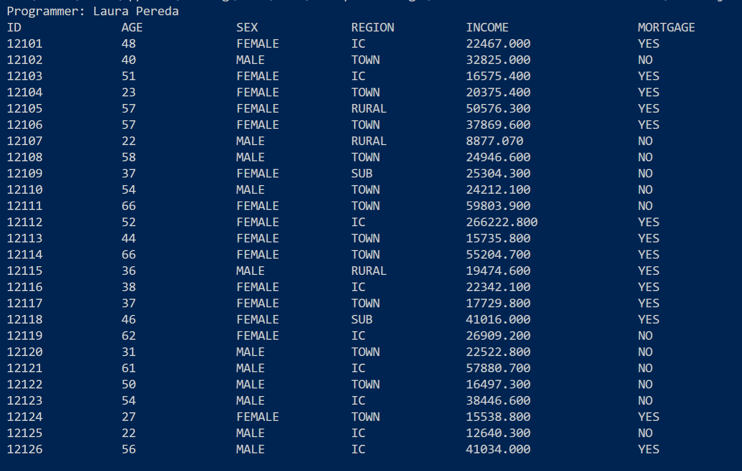

This is the result from printData(). In order to create neat columns, I had to modify the ID column by removing ‘id’ from each object. It was redundant and shifted the other columns. I also adjusted the income column to display up to three decimal points since it was also disrupting the neat column formatting.

**Note:** In this lab, I had found it unnecessary to have three separate functions to accomplish this task. I ended up combining the functions readData() and processData(). I have spoken to the professor regarding this change and was told he would verify with you. Aside from that, everything else is the same.